**Lab 1: Basic Linux Commands**

**Name: Tejaswini Wanare Roll No.: 48 PRN no.: 12111129**

**General Purpose Commands**

1. **date:**

* To display current date & time of the system.

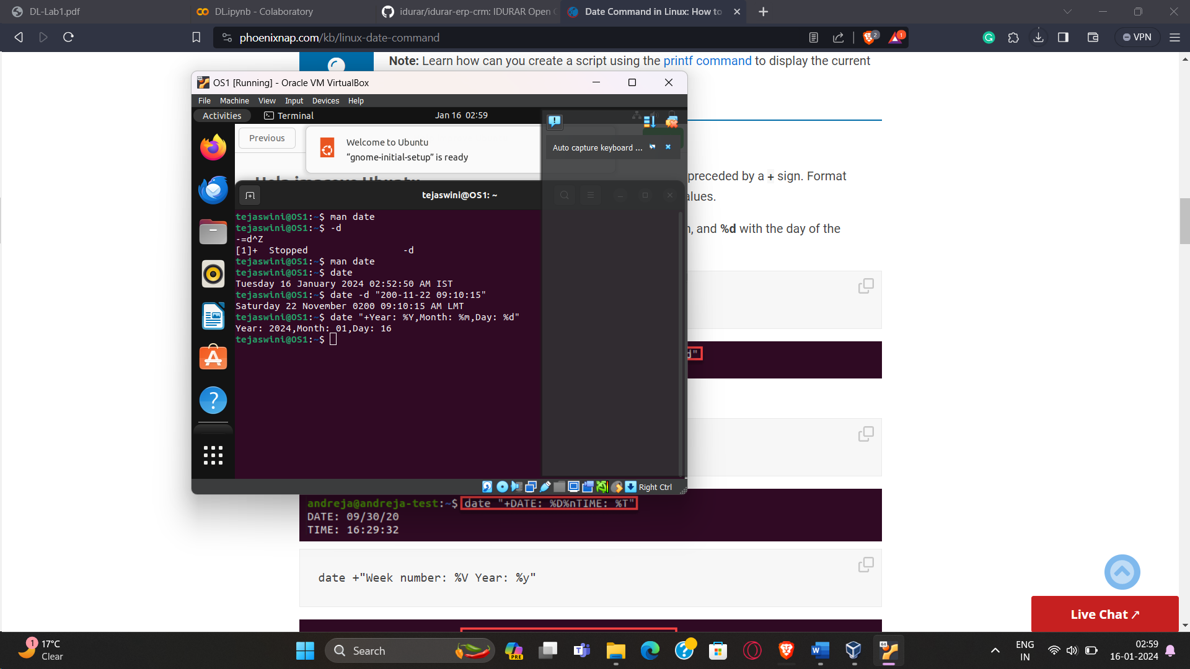

1. **cal :**

* To display calendar of current month.

1. **who:**

* List who is currently logged on to the system.

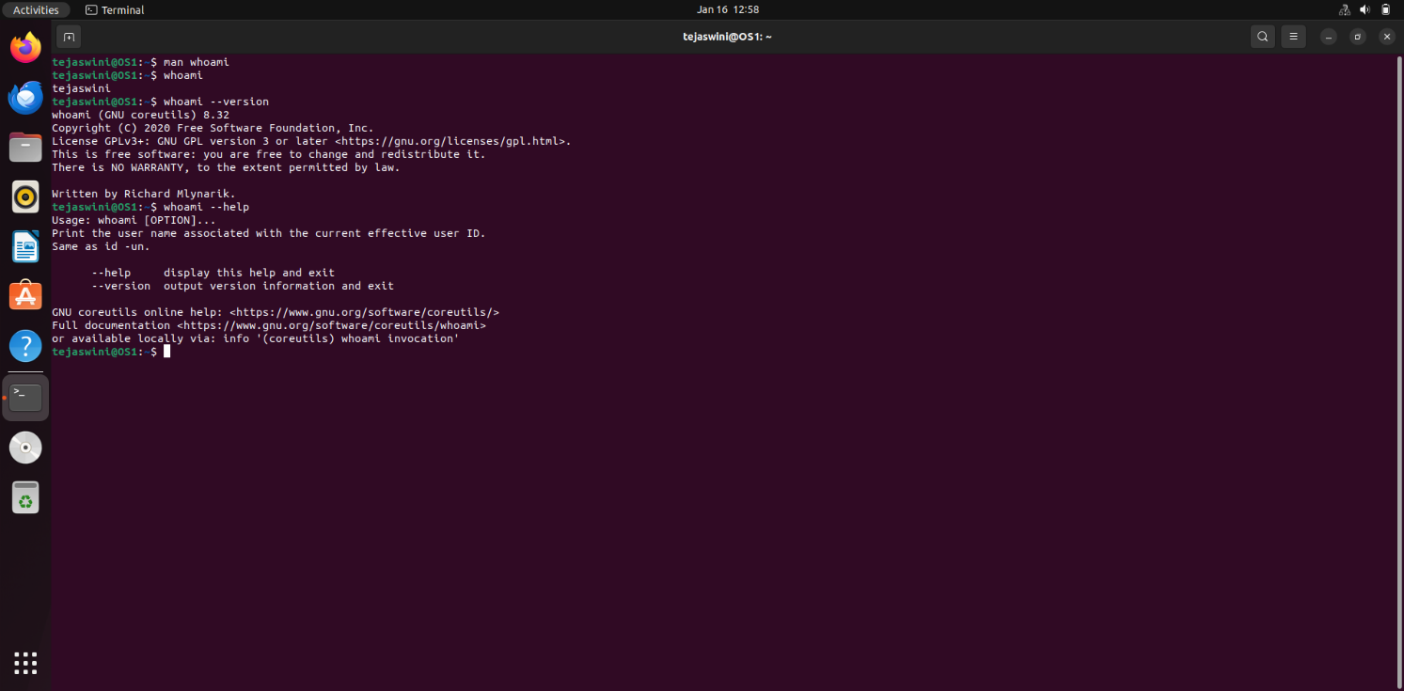

1. **Whoami:**

* Report what user you are logged on as.

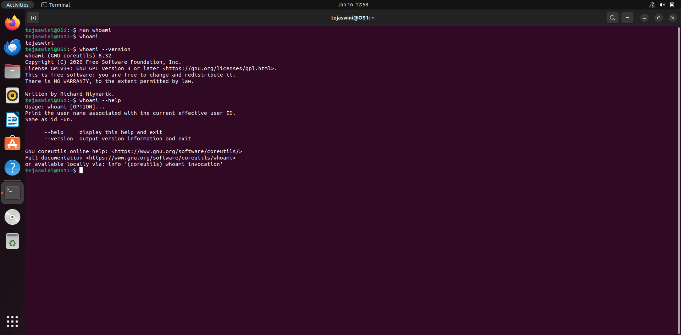

1. **echo :**

* Echo a string (or list of arguments) to the terminal

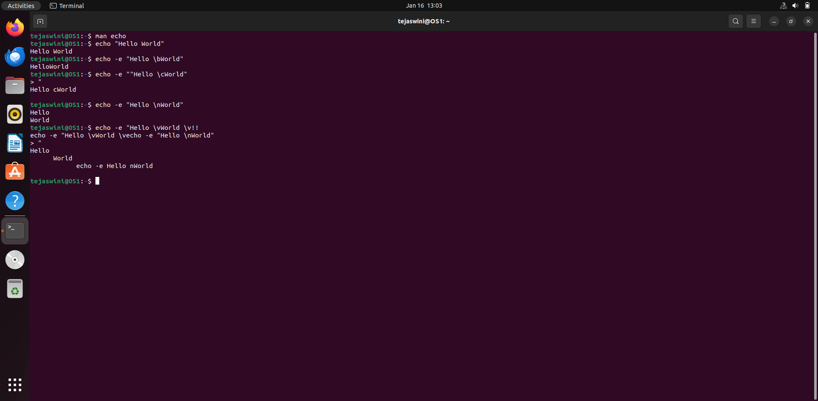

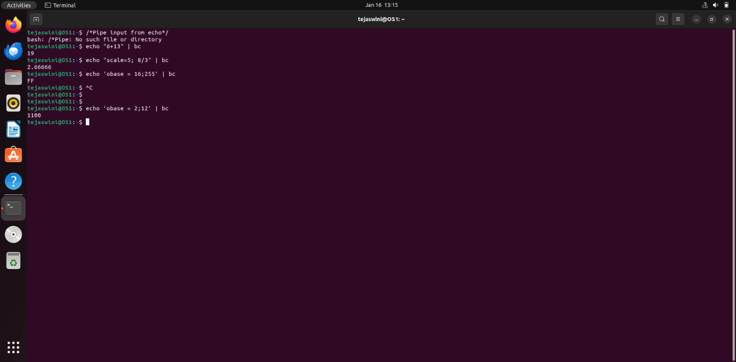

1. **bc:**

* To perform mathematical operations

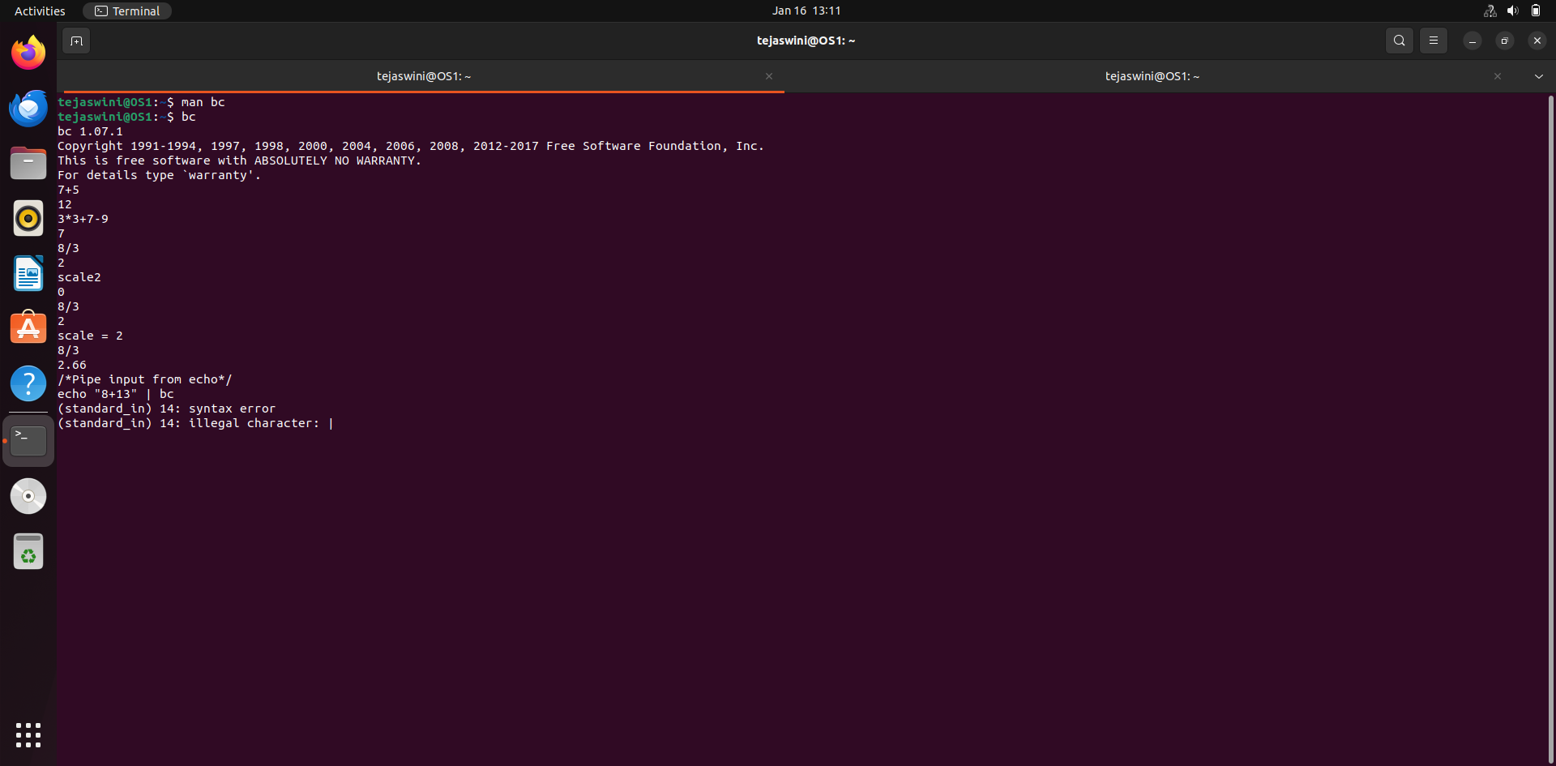

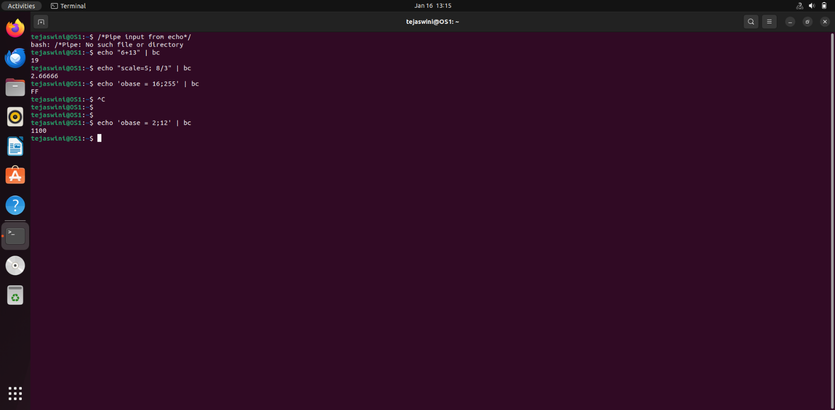

1. **clear:**

* To clear the screen

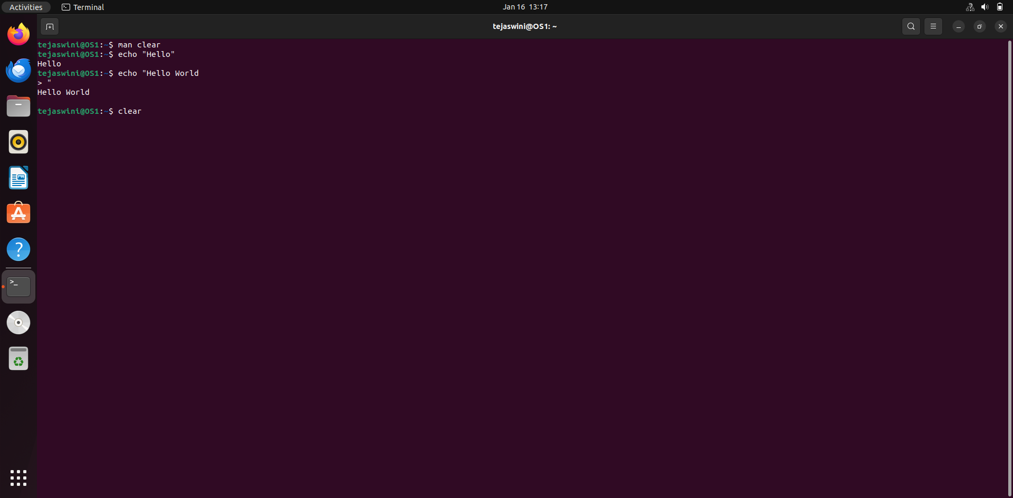

1. **alias :**

* Used to tailor commands
* Ex alias erase=rm Generate an employee report using AWK programming.
* alias grep=”grep -i”
* alias cp=“cp –i”

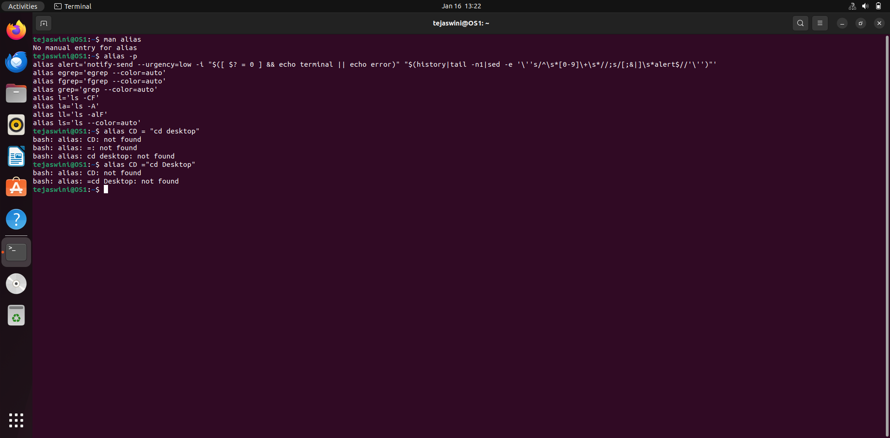

1. **man <cmd name>:**

* To get help for any command

1. **passwd:**

* To change password.

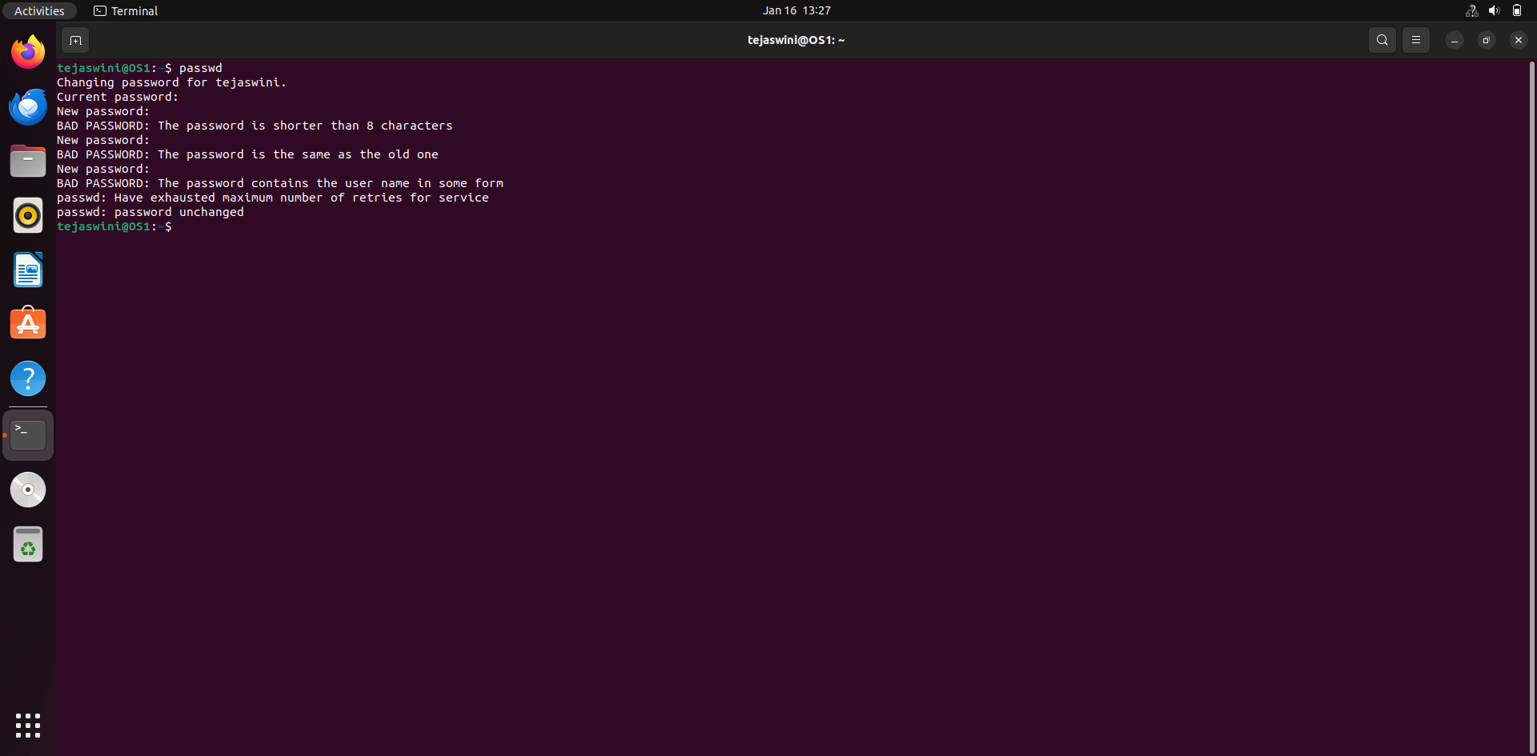

------------------------------------------------------

**File & Directory Related Commands**

**1. cp <fromfile> <tofile>:**

* Copy from the <fromfile> to the <tofile>

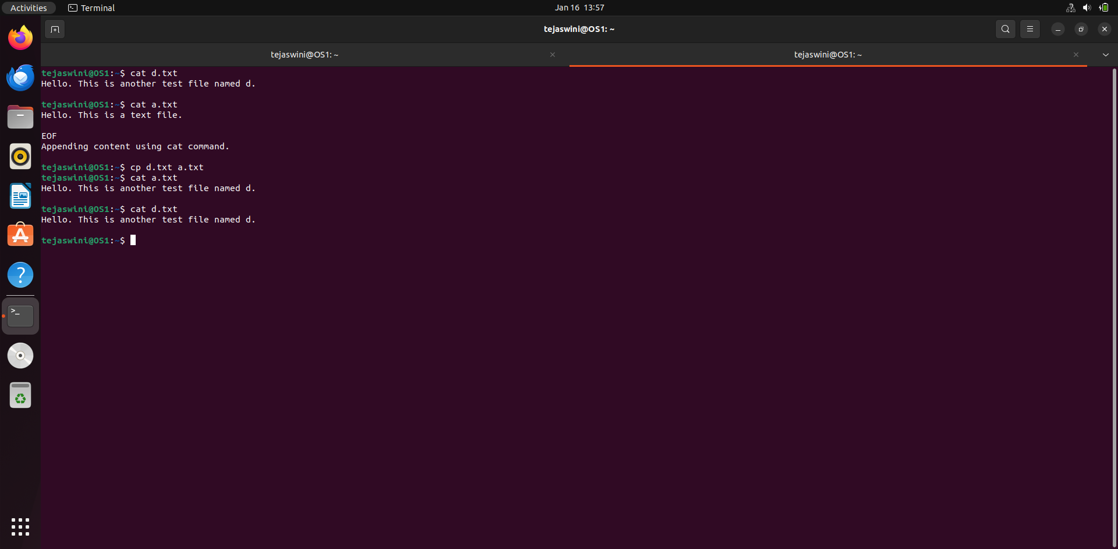

**2. mv <fromfile> <tofile> :**

* Move/rename the <fromfile> to the <tofile>

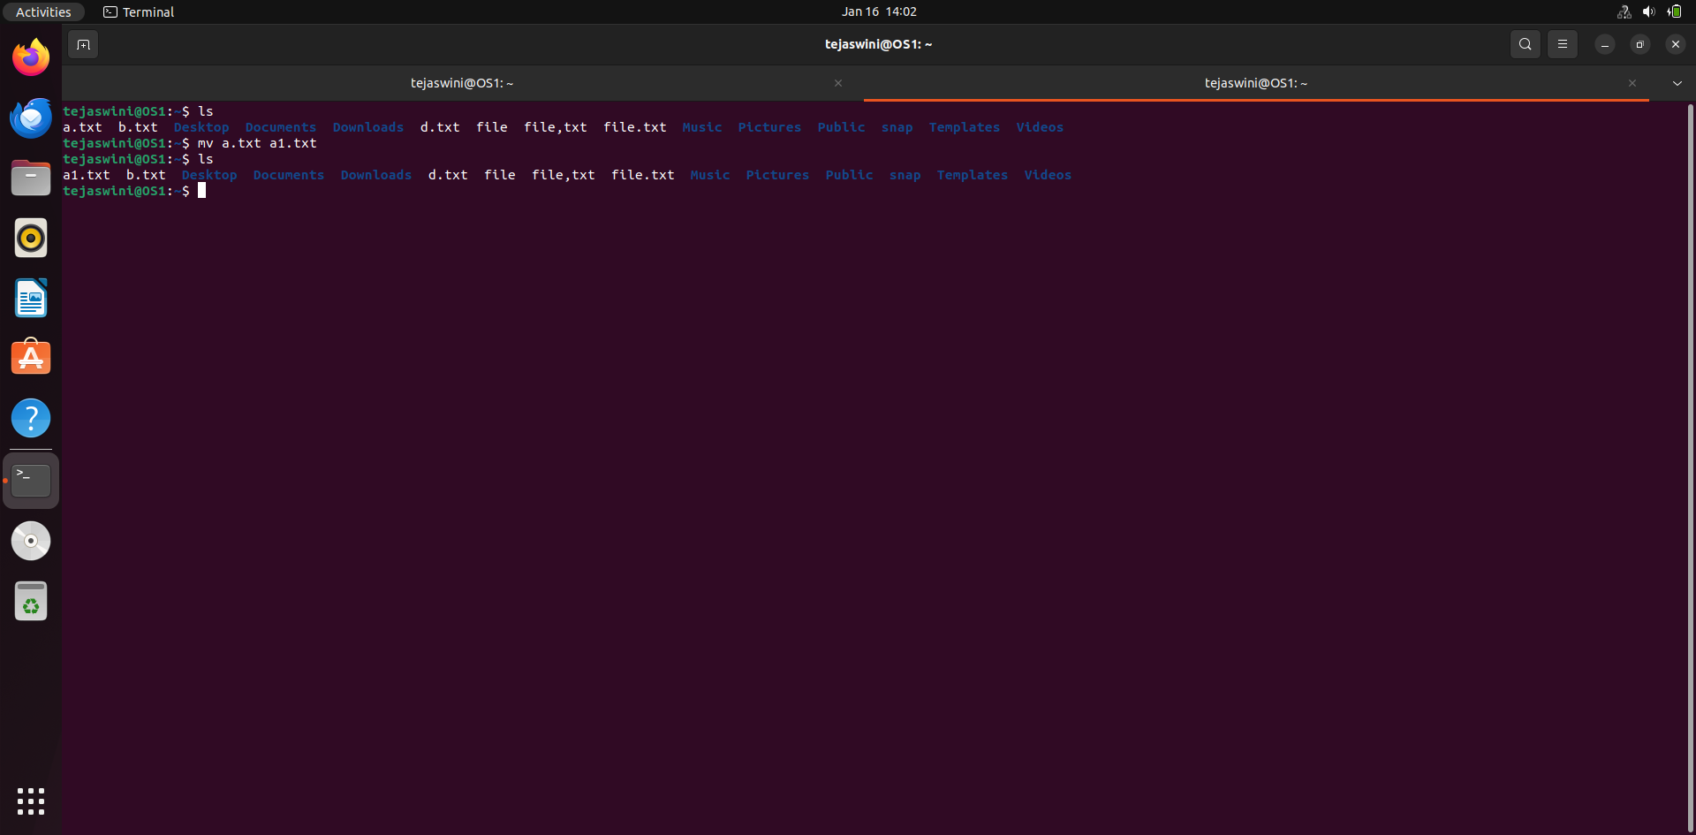

**3. rm <file>:**

* Remove the file named <file>

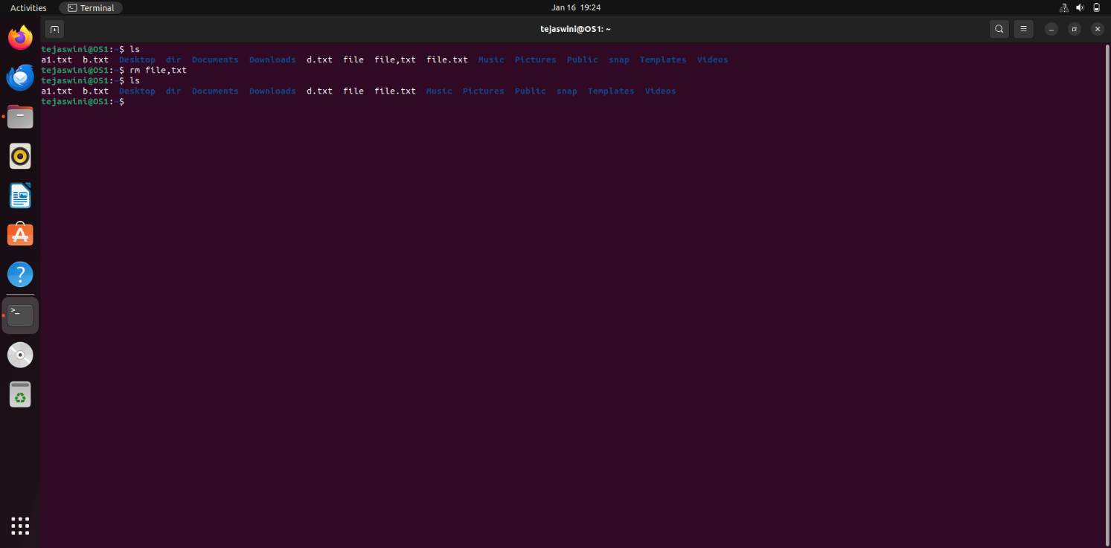

**4. mkdir <newdir>:**

* Make a new directory called <newdir>

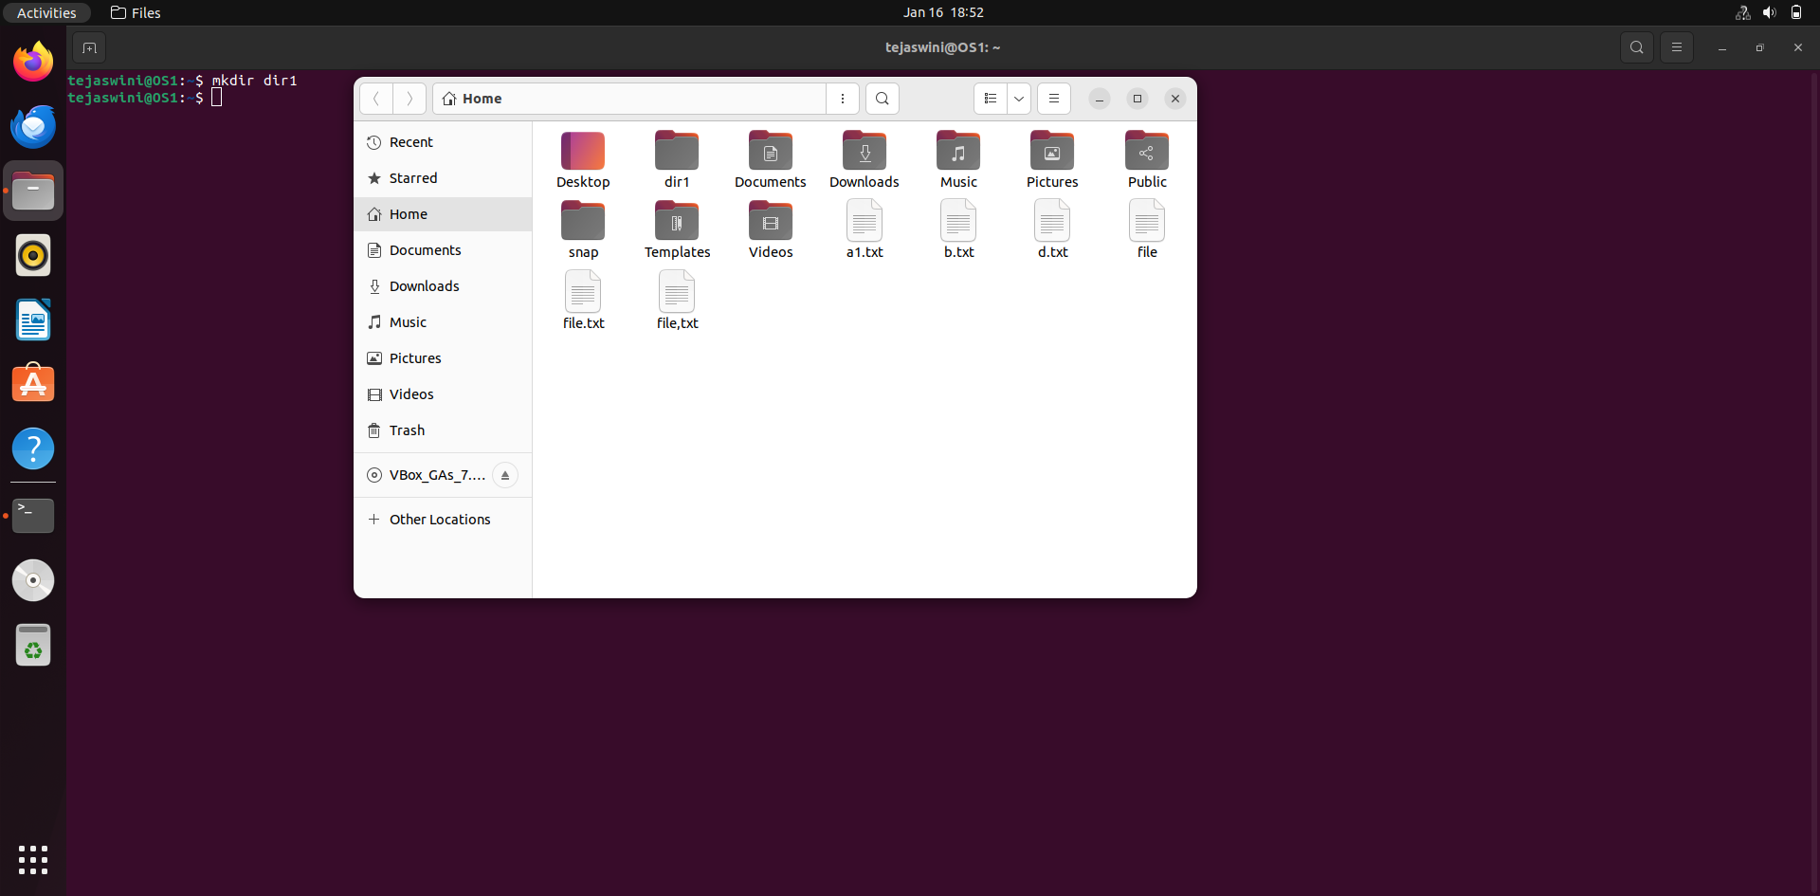

**5. rmdir <dir>:**

* Remove an (empty) directory

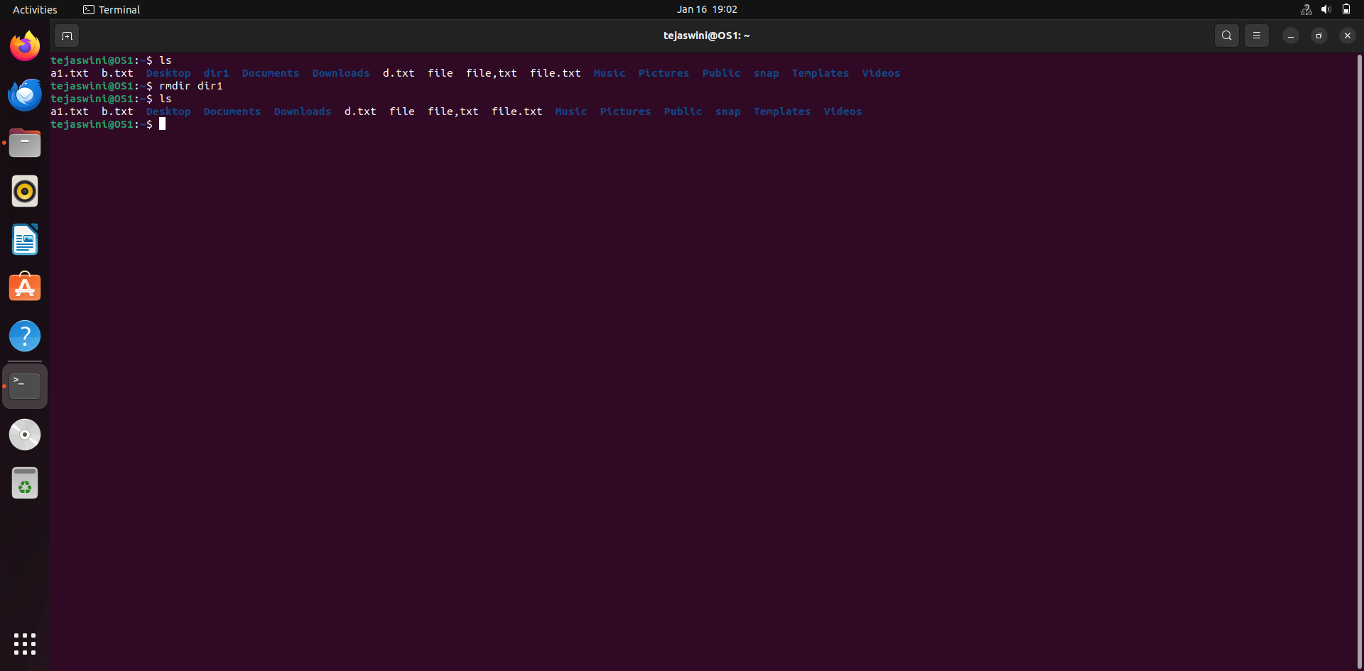

**6. cd <dir> :**

1. Change the current working directory to dir

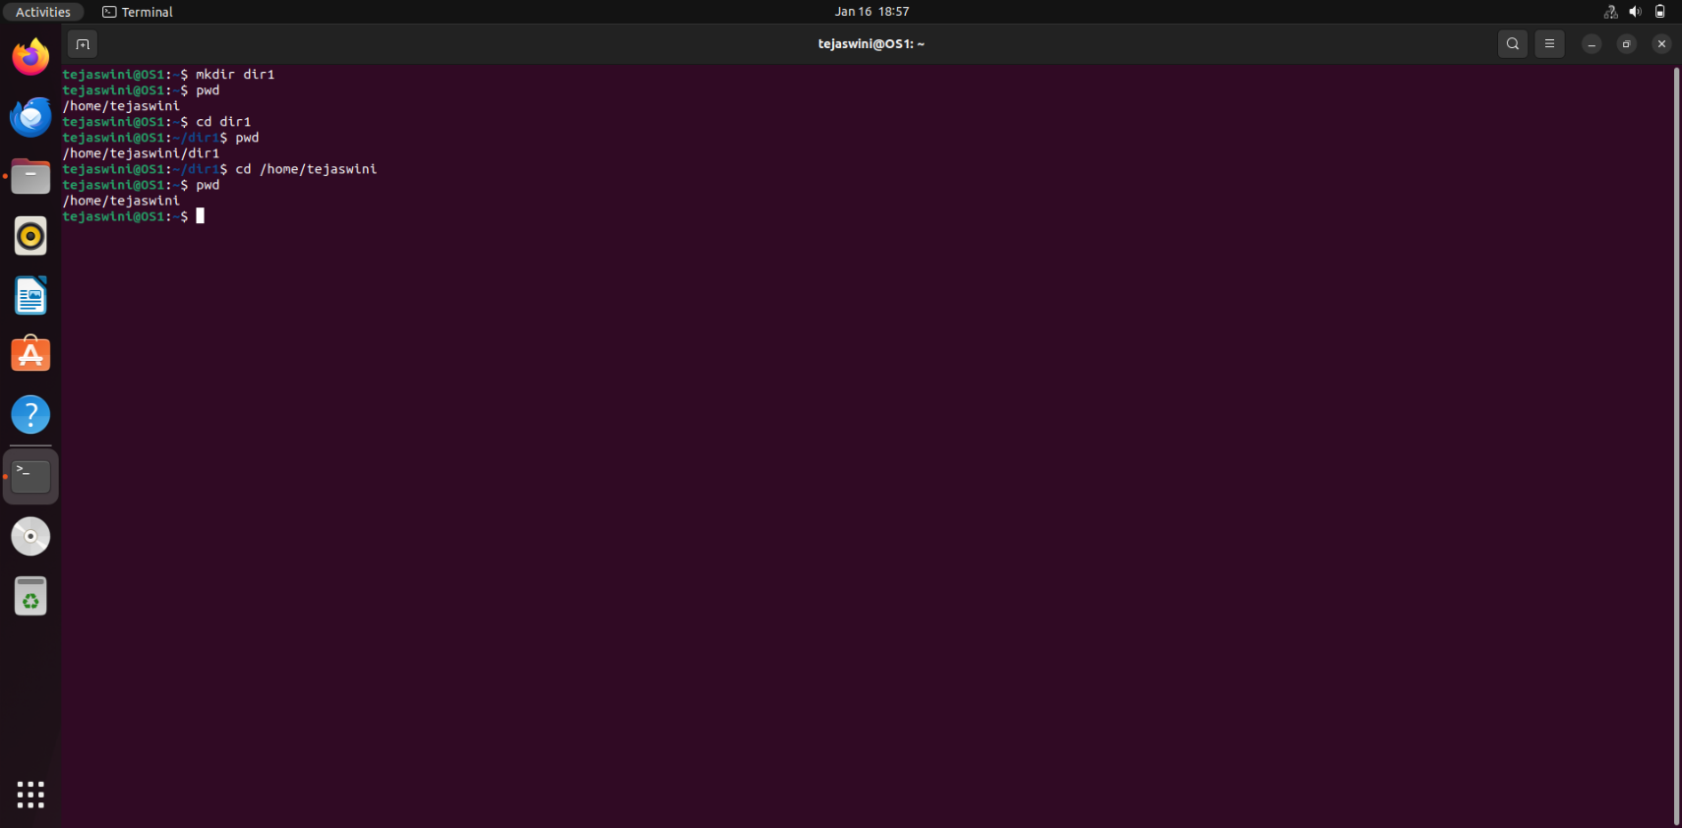

**7. pwd :**

1. Print (display) the working directory

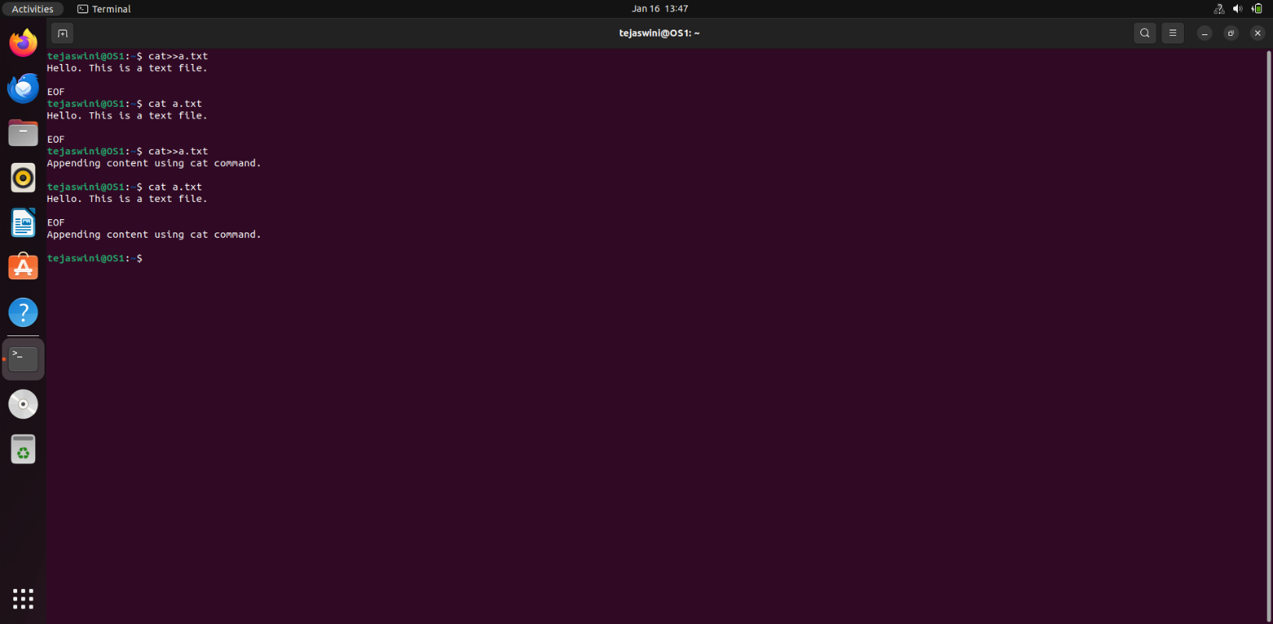

**8. cat > <file> :**

* To create new file n save it by pressing ^d

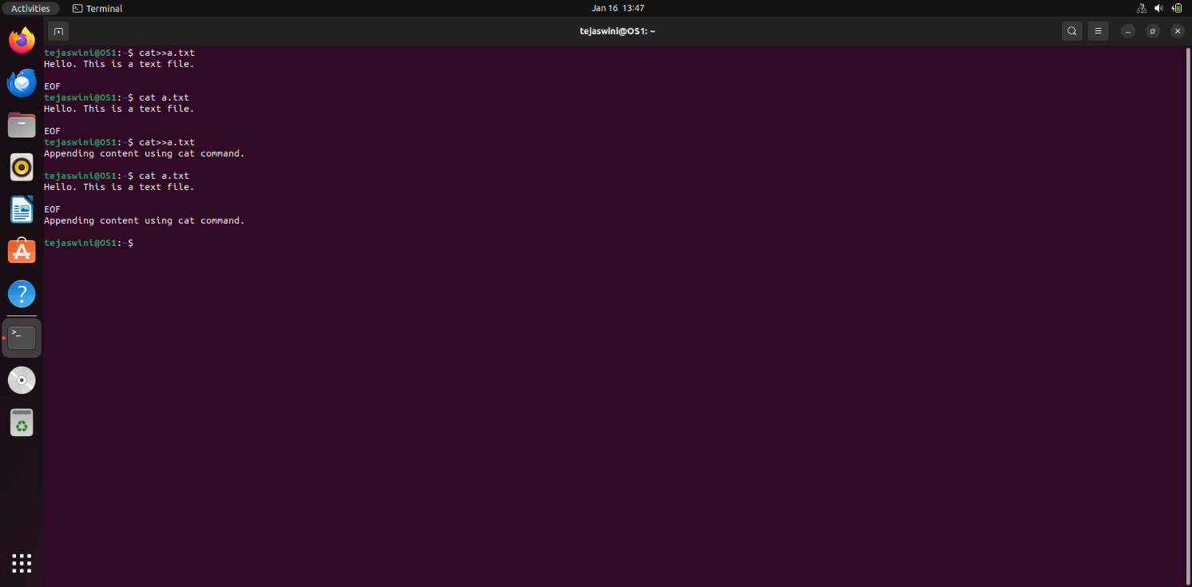

**9. cat >> <file>:**

1. To append contents into file

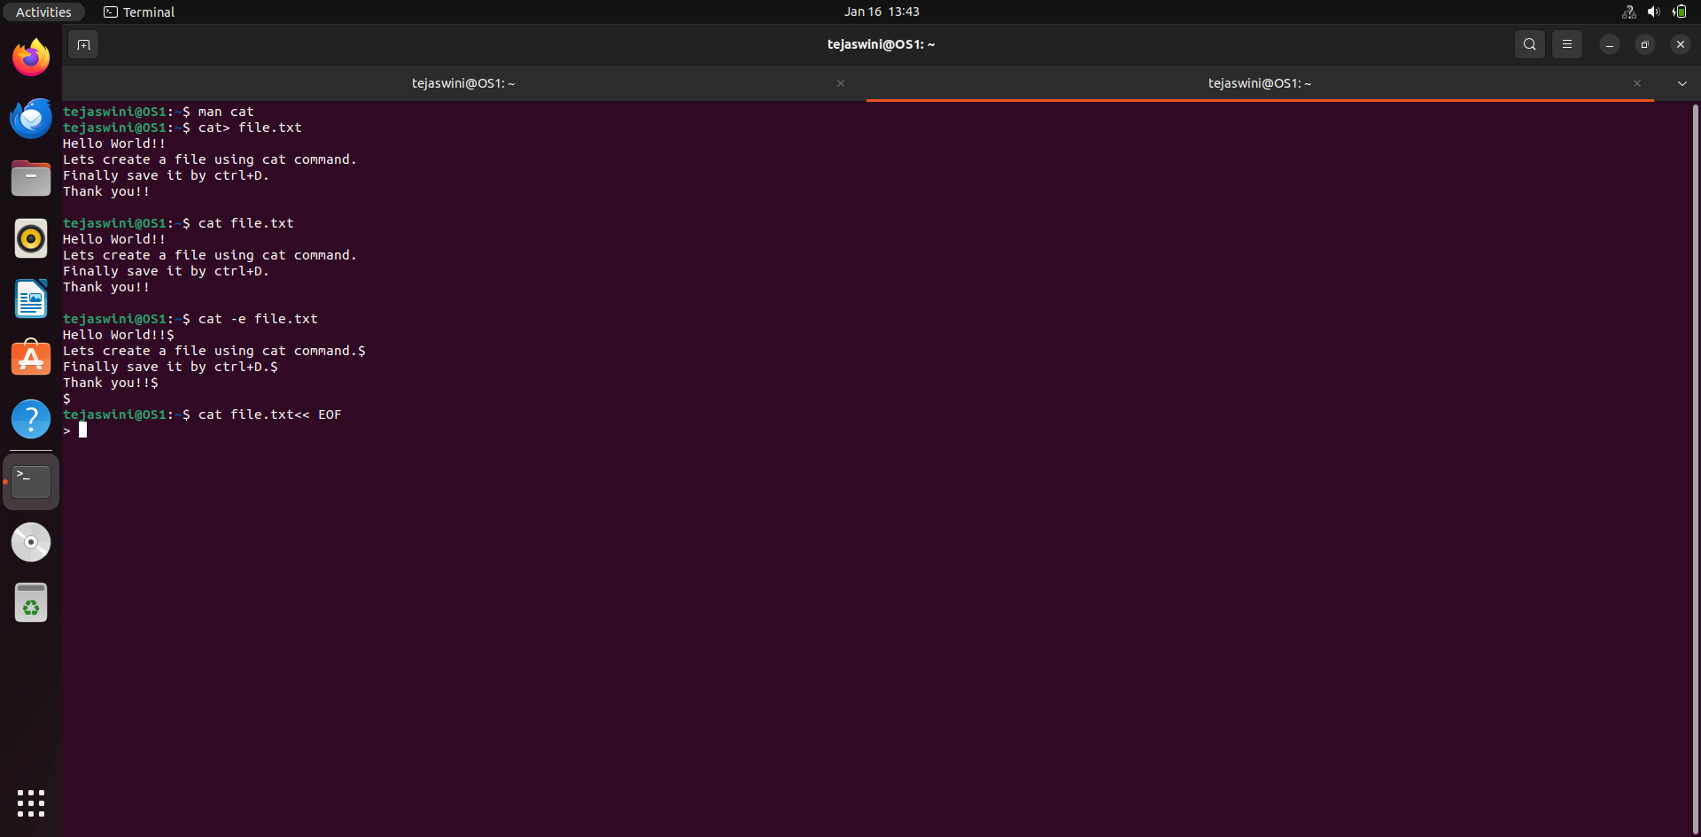

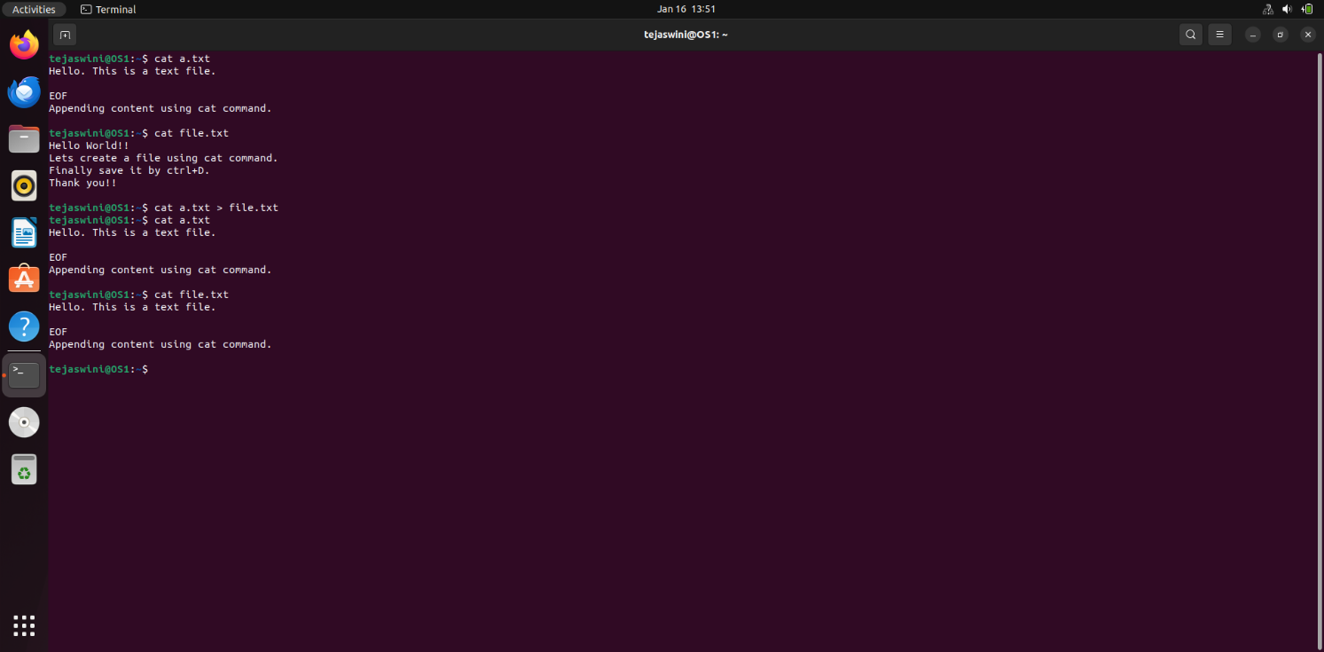

1. **cat <file>:**
2. To see the contents of existing file



1. **more <file>:**

* Paging out the contents of file

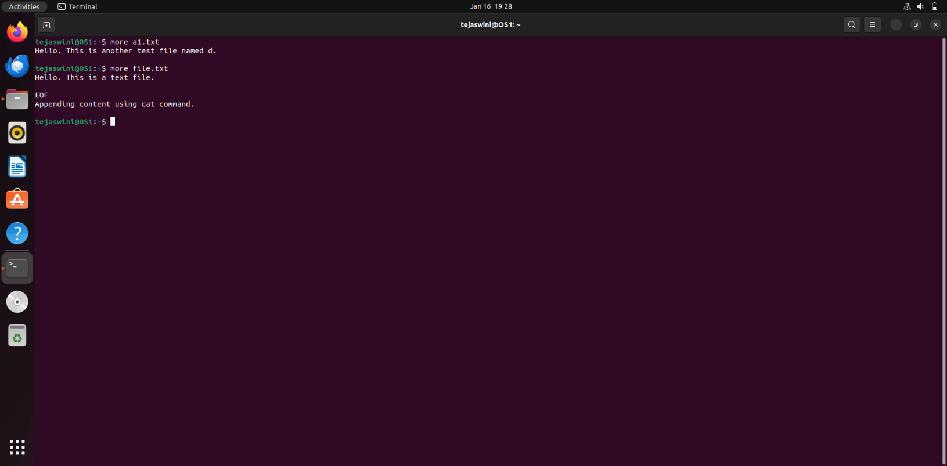

1. **file <file>:**

* To check the type of file

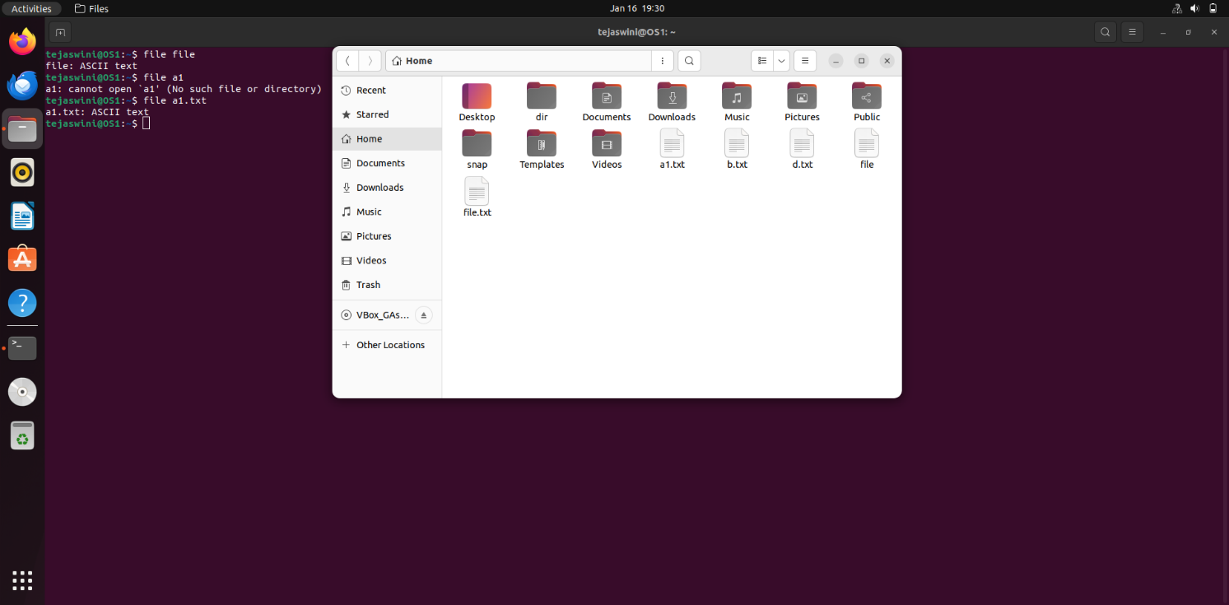

1. **wc <file>:**

* To count lines,words,charaters of file

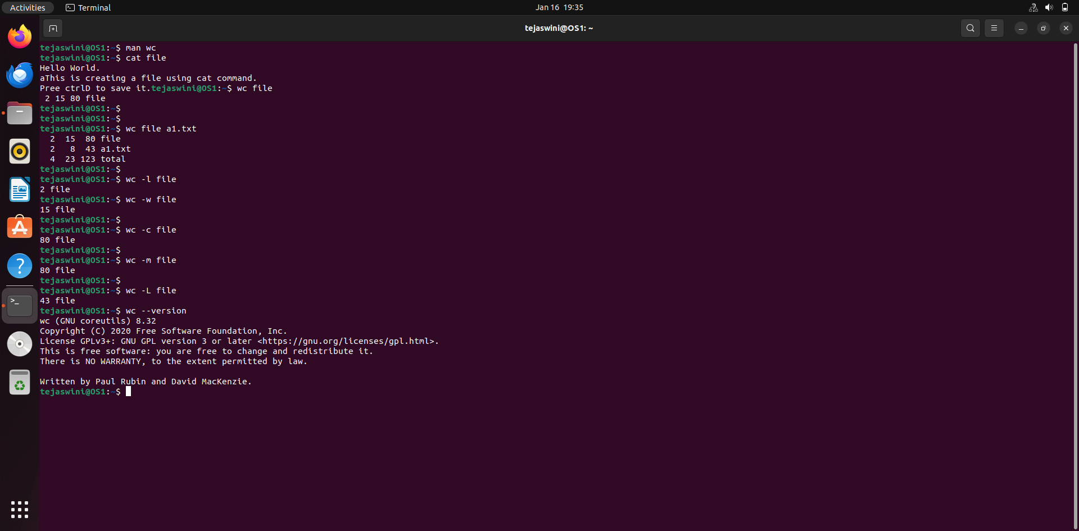

1. **cmp <file1> <file2>:**

* To compare two files

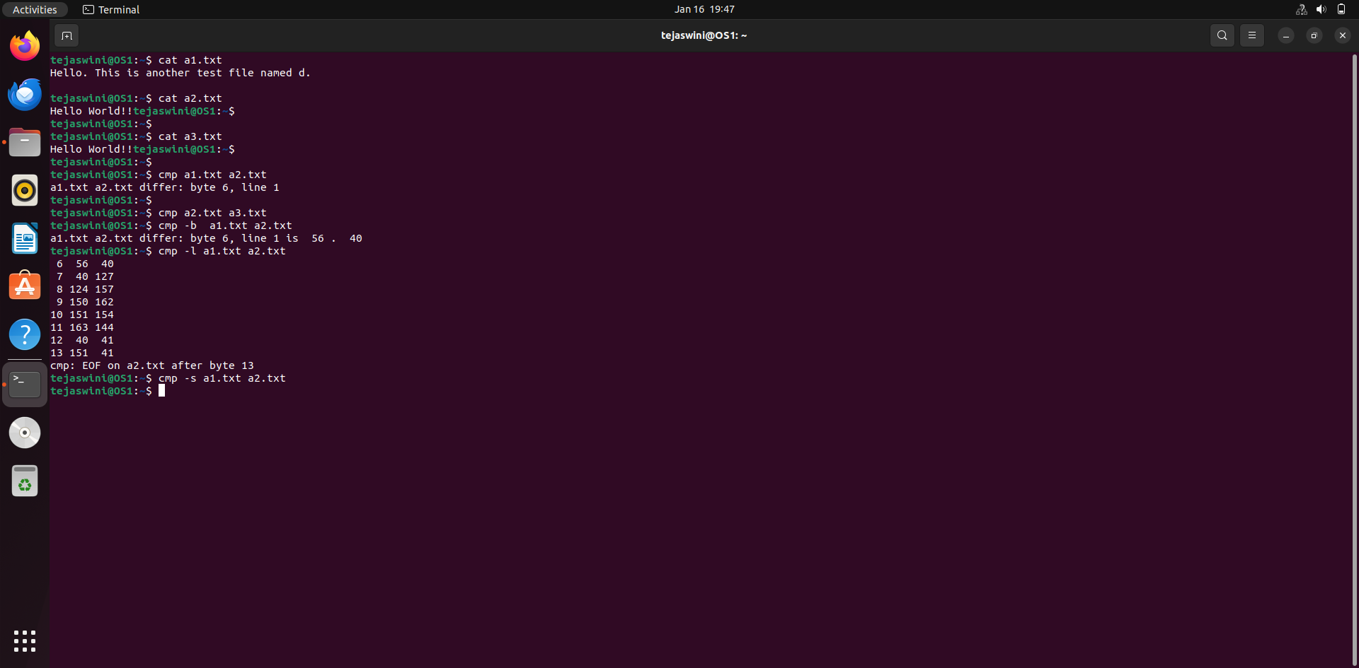

1. **comm <file1> <file2>:**

* To display common values between two files

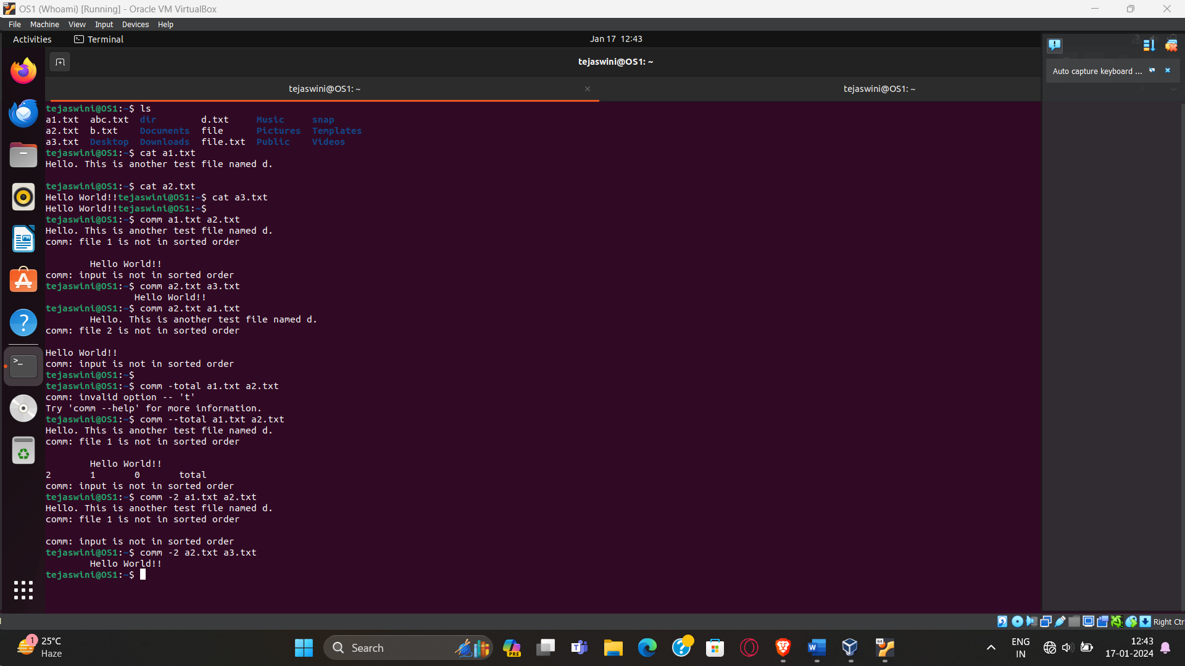

1. **diff <file1> <file2>:**

* To convert one file to another

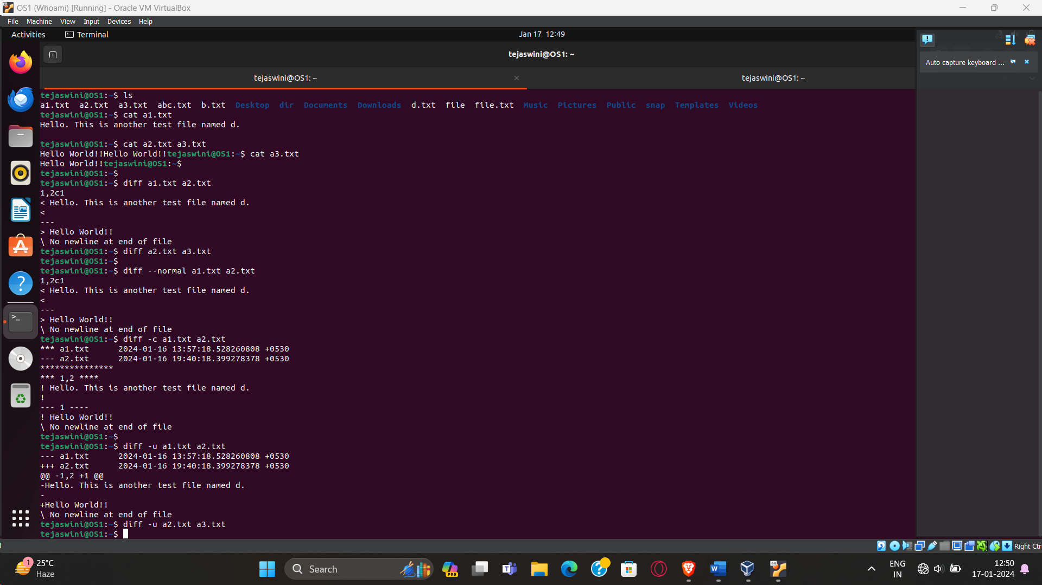

1. **gzip <file>:**

* To compress the file

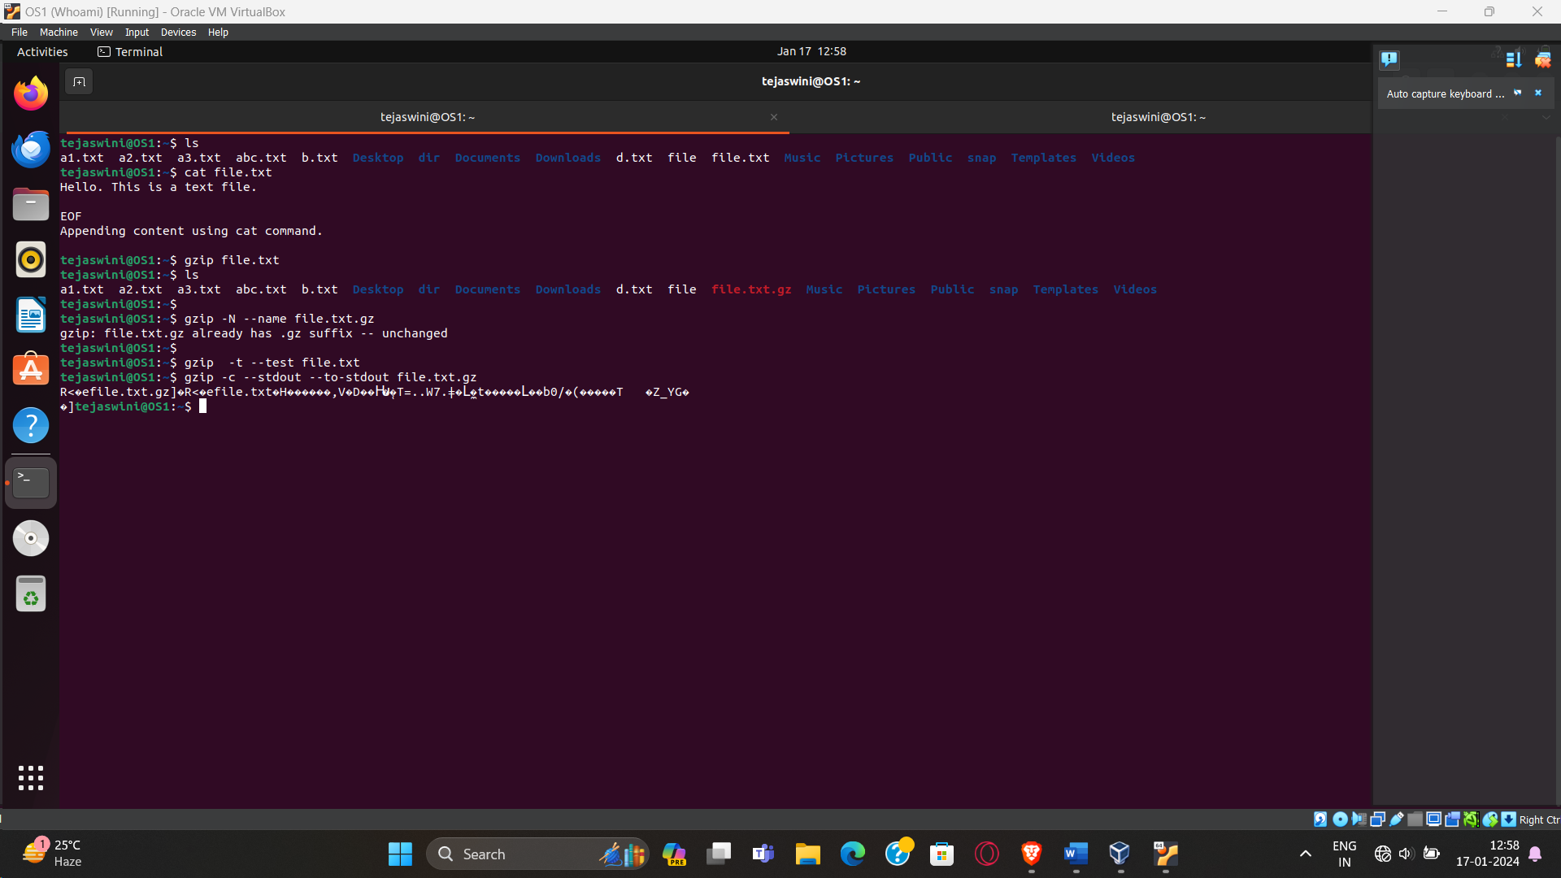

1. **gunzip <file>:**

* To unzip the contents of zipped file

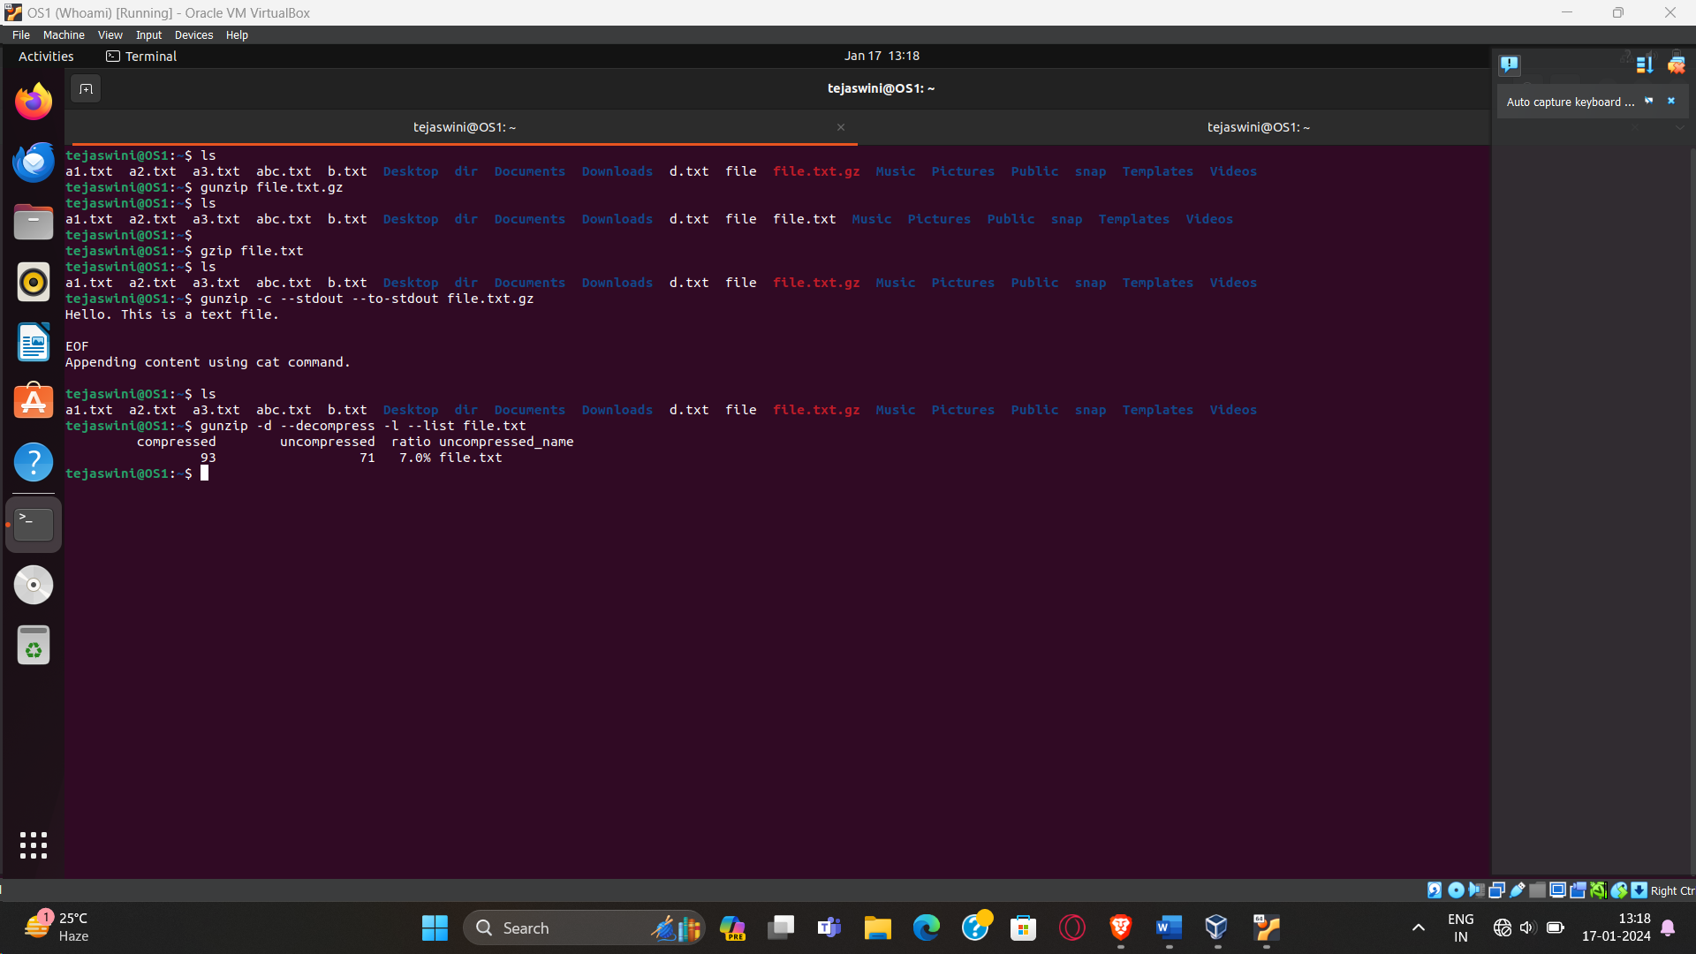

1. **ls :**

* List the files in the current working directory

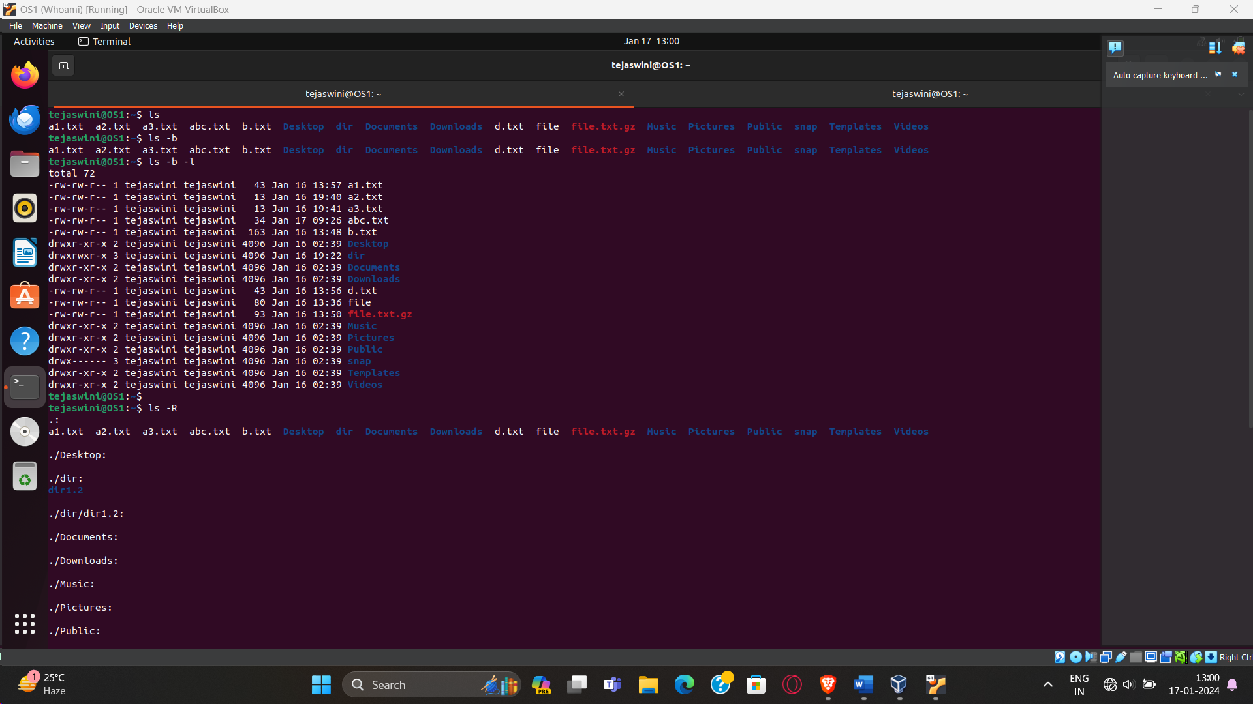

1. **ls -r:**

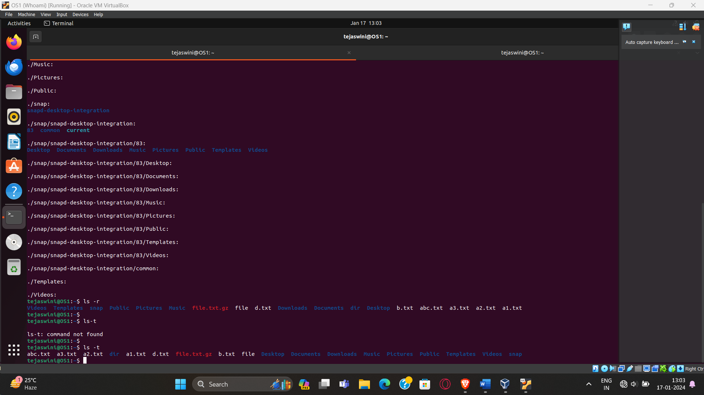

1. **ls <dir>:**

* List all files & directories in given directory

